**Generalarzt Dr. med dent Rolf von Uslar, M.A.  
Direktor Multinational Medical Coordination Centre - Europe**

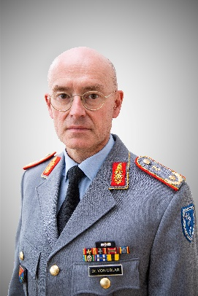

**Brigadier General (DD) Rolf von Uslar, M.A.**

**Specialist in Dentistry**

Born: 09. August 1969

Marital Status: married, 2 Daughters

**Werdegang**

1988 Entry into military service as medical officer cadet, 12 Medical

Bataillon (SanBtl), Veitshöchheim

1988 – 1989 Pre-training at Infantry School Hammelburg; Bundeswehr Hospital in Amberg; Bundeswehr Medical Academy, Munich and 12 Medical Battalion (SanBtl)

1989 – 1994 Dental school at Julius Maximilians University of Würzburg  
 Adolf-and-Inka-Lübeck Prize

1994 – 1995 Military dentist at Dental Clinic 133 Transport Battalion, Erfurt

1995 Chief Dental Clinic 571 Mountain Infantry Battalion, Schneeberg

1995 – 1998 Chief Dental Clinic 371 Infantry Battalion, Marienberg

1998 – 2001 Assistant Head of Department I 1 Dental Medicine, Bundeswehr Medical Office, Bonn

2001 – 2003 Chief Dental Clinic at RHQ AFNORTH, Brunssum/NLD

2003 – 2004 Assistant Head of medical planning, JMed, Bundeswehr Operations

Command, Schwielowsee

2004 – 2006 National General/ Staff Officer Course, Bundeswehr Command and Staff College in Hamburg

2006 – 2007 Head of Department G3.1 “Response Forces”, Medical Forces Command, Koblenz

2008 – 2011 Federal Ministry of Defence, Joint Medical Staff, Assistant Branch Chief, Bonn

2011 Staff Officer MedOps/Plans CJMED, ISAF Headquarters, Kabul

2012 – 2013 Commander Medical Training Regiment „Lower Bavaria”, Feldkirchen

2013 – 2016 Head of Department I 1 plans and policy, concept development and international cooperation; Bundeswehr Medical Service Headquarters, Koblenz

2016 – 2017 Head of the Faculty of Medical Support and Health Sciences,

German Armed Forces Command and Staff College, Hamburg

Postgraduate studies (Master of Arts) on „Military Leadership and International Security (MFIS)“ at Helmut Schmidt University of the German Armed Forces, Hamburg

2017 – 2019 Head of Division VIII „Organization and Infrastructure“,

Bundeswehr Medical Service Headquarters, Koblenz

2019 – 2022 Chief of Branch Forces Policy, Medical Plans and Policy,

Federal Ministry of Defense, Berlin

2022 – 2023 Chief of Division Forces Policy, Medical Support,

Federal Ministry of Defense, Berlin

2023 – 2024 Deputy Commander of Regional Medical Support Command, Diez

since 10/24 Director Multinational Medical Coordination Centre – Europe,

Koblenz

**Einsatzerfahrung**

2011 International Security Assistance Force (ISAF)

**Auszeichnungen**

1995: Adolf-and-Inka-von-Lübeck award

2007: Cross of Honour of the German Armed Forces in silver

2010: Cross of Honour of the German Armed Forces in gold

2011: NATO medal ISAF

2011: ISAF Service Medal of the German Armed Forces

2013: Service Medal „Flood Relief“ (flooding in Central Europe in 2013)